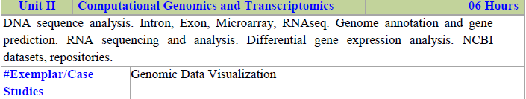

DNA Sequence Analysis involves examining the sequence of nucleotides (adenine [A], thymine [T], cytosine [C], and guanine [G]) in a DNA molecule to understand its structure, function, and evolution. This analysis is a fundamental part of genomics and molecular biology, providing insights into genetic diseases, evolutionary biology, and biotechnology.

Key Components of DNA Sequence Analysis:
DNA Sequencing:
  - The process of determining the exact order of the nucleotides in a DNA molecule.
  - Several methods, such as Sanger sequencing and Next-Generation Sequencing (NGS), are used to determine the sequence.
  - Sanger sequencing is based on selective incorporation of chain-terminating dideoxynucleotides, whereas NGS techniques like Illumina sequencing allow for rapid sequencing of large DNA samples.
Data Acquisition and Preprocessing:
  - The obtained raw data from sequencing machines is often in the form of chromatograms or FASTQ files.
  - Preprocessing involves quality control checks, trimming low-quality sequences, and removing adapters or contaminants.
Sequence Alignment:
  - The process of arranging DNA sequences to identify regions of similarity that may indicate functional, structural, or evolutionary relationships.
  - Tools like BLAST (Basic Local Alignment Search Tool) or ClustalW are used for local and global alignments, respectively.
  - Alignment helps in identifying mutations, conserved regions, or evolutionary relationships among different organisms.

Applications of DNA Sequence Analysis:
- Genetic Research and Medicine: Helps in identifying disease-causing mutations, understanding genetic disorders, and developing personalized medicine.
- Forensic Science: DNA fingerprinting and profiling for solving crimes, identifying remains, or verifying biological relationships.
- Agriculture: Used in crop improvement by identifying and introducing favorable traits through selective breeding or genetic engineering.
- Evolutionary Biology: Helps trace the evolution of species, study genetic diversity, and understand evolutionary mechanisms.

Tools and Technologies:
- Software like BLAST, Bowtie, BWA (Burrows-Wheeler Aligner) for sequence alignment.
- Genome browsers like UCSC Genome Browser or Ensembl for visualization and annotation.
- Python and R programming languages for custom data analysis and statistical modeling.
Conclusion: DNA Sequence Analysis is a critical field in modern biology that provides valuable insights into genetic information, paving the way for advances in medicine, agriculture, and evolutionary studies. It involves multiple steps, from data acquisition to functional annotation, each contributing to our understanding of DNA's role in life.

Maxam-Gilbert Sequencing (3 Marks)
Overview: Maxam-Gilbert sequencing, also known as the chemical cleavage method, was developed by Allan Maxam and Walter Gilbert in 1977. It involves the chemical modification and subsequent cleavage of DNA at specific bases to determine the nucleotide sequence.
Methodology:
  - DNA Labeling: A single-stranded DNA is radioactively labeled at the 5' end.
  - Chemical Cleavage: The DNA is divided into four separate reactions, each treated with a different chemical that specifically cleaves the DNA at one of the four bases (A, T, C, or G).
  - Gel Electrophoresis: The resulting fragments are separated by size using polyacrylamide gel electrophoresis. The gel is then exposed to X-ray film to visualize the radioactive fragments, revealing the DNA sequence based on fragment lengths.
Advantages and Limitations:
  - Advantages: Accurate for short DNA sequences and does not require a DNA polymerase or primer.
  - Limitations: Involves the use of hazardous chemicals and is labor-intensive. It has largely been replaced by more modern techniques like Sanger and next-generation sequencing.

Sanger Sequencing (3 Marks)
Overview: Developed by Frederick Sanger in 1977, Sanger sequencing, also known as the chain-termination method, is the most widely used DNA sequencing technique for decades. It relies on the selective incorporation of chain-terminating dideoxynucleotides (ddNTPs) during DNA replication.
Methodology:
  - DNA Amplification: The target DNA is amplified by PCR. During replication, both regular deoxynucleotides (dNTPs) and fluorescently labeled dideoxynucleotides (ddNTPs) are added.
  - Chain Termination: Incorporation of a ddNTP prevents further elongation of the DNA strand, resulting in fragments of varying lengths, each ending with a labeled ddNTP.
  - Capillary Electrophoresis: The fragments are separated by size using capillary electrophoresis. A laser detects the fluorescent labels, and a computer generates a chromatogram displaying the DNA sequence.

Advantages and Limitations:
  - Advantages: High accuracy and reliability, especially for sequencing small regions of DNA (up to 1,000 base pairs).
  - Limitations: Time-consuming and expensive for large-scale sequencing projects compared to next-generation sequencing methods.

Next-Generation Sequencing (NGS) (3 Marks)
Overview: Next-Generation Sequencing (NGS) refers to a group of advanced sequencing technologies that allow for rapid and high-throughput sequencing of large amounts of DNA. Unlike traditional Sanger sequencing, NGS can sequence millions of fragments in parallel, making it faster, cheaper, and more scalable.
Methodology:
  - Library Preparation: DNA is fragmented and adapters are added to both ends of each fragment. These adapters allow the fragments to attach to a sequencing platform.
  - Cluster Generation and Amplification: The DNA fragments are bound to a solid surface, and each fragment is clonally amplified to form clusters using techniques like bridge amplification (Illumina) or emulsion PCR (Ion Torrent).
  - Massively Parallel Sequencing: Sequencing by synthesis (e.g., Illumina) or sequencing by ligation (e.g., SOLiD) occurs, where nucleotides are added one by one, and the sequence is determined based on the emitted signal (fluorescence or pH change).
Advantages and Limitations:
  - Advantages: Extremely high throughput, cost-effective for large-scale sequencing projects (like whole-genome sequencing), and allows for simultaneous analysis of multiple samples.
  - Limitations: Requires complex data analysis, shorter read lengths compared to Sanger sequencing, and potential challenges with sequencing repetitive regions of the genome.

Intron (3 Marks)
Definition: Introns are non-coding sequences of DNA within a gene that are transcribed into RNA but are removed during RNA splicing. They do not contribute to the final mature mRNA and hence are not translated into proteins.
Function:
  - Regulation: Introns may play a role in regulating gene expression by influencing the timing and efficiency of RNA splicing and mRNA export from the nucleus.
  - Evolution: Introns allow for alternative splicing, enabling a single gene to produce multiple proteins. They also provide sites for recombination, contributing to genetic diversity and evolution.
Characteristics:
  - Introns are typically larger than exons and vary greatly in size.
  - They contain specific sequences at their ends (splice sites) that signal where splicing should occur.
  - Introns are prevalent in eukaryotic genomes but are generally absent in prokaryotic genomes.

Exon (3 Marks)
Definition: Exons are coding sequences of DNA within a gene that are transcribed into RNA and remain in the mature mRNA after splicing. They are the portions of a gene that are translated into proteins.
Function:
  - Protein Coding: Exons contain the actual information needed to synthesize proteins, with each exon typically corresponding to a particular domain or functional unit of the protein.
  - Gene Expression: Exons can be involved in regulatory processes, such as defining the start and stop of translation and interacting with other regulatory elements.
Characteristics:
  - Exons are usually shorter than introns and are joined together during RNA splicing to form the continuous coding sequence of mRNA.
  - They are found in both eukaryotic and prokaryotic genomes.
  - Alternative splicing can include or exclude certain exons, allowing a single gene to produce multiple proteins with different functions.

Conclusion:
Introns and exons are essential components of eukaryotic genes. While introns are non-coding and removed during RNA processing, exons carry the coding information required for protein synthesis. Both contribute to gene regulation, evolution, and the generation
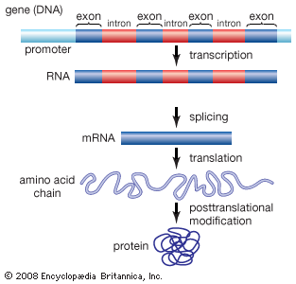

Microarray (5 Marks)
- Overview: A microarray is a high-throughput technology used to simultaneously measure the expression levels of thousands of genes or detect various nucleic acid sequences. It consists of a solid surface, typically a glass slide or silicon chip, onto which thousands of DNA sequences are immobilized in a grid-like pattern. Microarrays are widely used in genomics for gene expression profiling, genetic variation analysis, and biomarker discovery.
3. Applications:
Gene Expression Profiling: Microarrays are used to measure the expression levels of thousands of genes simultaneously, providing insights into gene activity in different conditions, tissues, or disease states. This is useful for understanding disease mechanisms, identifying biomarkers, and discovering potential therapeutic targets.
Genetic Variation Analysis: Microarrays can detect single nucleotide polymorphisms (SNPs) and other genetic variations across the genome, which is valuable for genetic association studies, personalized medicine, and understanding genetic predispositions to diseases.
Comparative Genomics: By comparing gene expression profiles between different conditions or species, researchers can identify conserved and divergent genetic pathways, contributing to evolutionary studies and functional genomics.

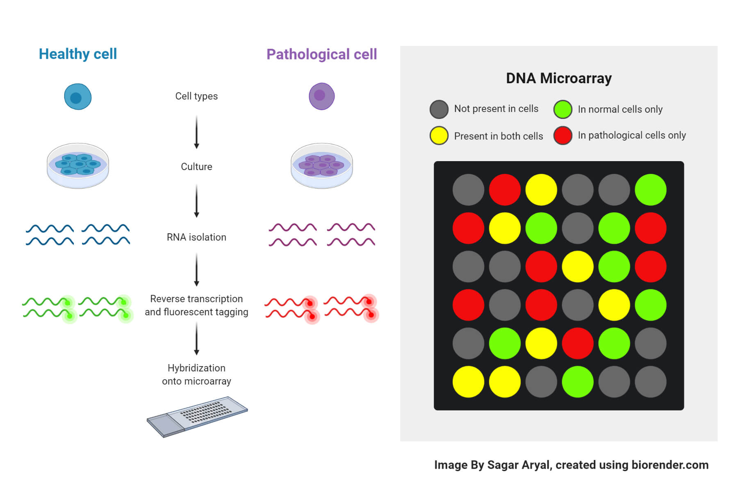
The image you sent illustrates the process of DNA microarray analysis, a technique used to study gene expression patterns in different cell types. Here's a breakdown of the steps involved:
1. Cell Culture:
- Healthy and pathological cells are cultured in separate dishes. This allows for the growth and proliferation of cells under controlled conditions.
2. RNA Isolation:
- RNA is extracted from both cell types. RNA molecules carry genetic information from DNA to ribosomes, where proteins are synthesized.
3. Reverse Transcription and Fluorescent Tagging:
- RNA is converted into complementary DNA (cDNA) using a process called reverse transcription.
- Fluorescent tags are attached to the cDNA molecules, allowing them to be visualized on the microarray.
4. Hybridization onto Microarray:
- The fluorescently labeled cDNA is applied to a DNA microarray, a glass slide containing thousands of tiny spots, each representing a specific gene.
- The cDNA molecules bind to complementary DNA sequences on the microarray, forming hybrids.
5. Analysis:
- The microarray is scanned to detect the fluorescence intensity of each spot.
- The intensity of the fluorescence signal corresponds to the abundance of the mRNA transcript for that gene.
- By comparing the gene expression patterns between healthy and pathological cells, researchers can identify genes that are differentially expressed in disease states.
Color Coding in the Microarray:
- The color coding in the microarray represents the relative expression levels of genes:
  - Gray: Gene is not present in either cell type.
  - Green: Gene is present in normal cells only.
  - Red: Gene is present in pathological cells only.
  - Yellow: Gene is present in both cell types.
In conclusion, DNA microarray analysis is a powerful tool for studying gene expression and identifying genes involved in various biological processes, including disease development and progression.
RNA Sequencing (RNA-seq)
RNA Sequencing (RNA-seq) is a powerful technique used to analyze the transcriptome of a cell or tissue, providing insights into gene expression, transcript structure, and alternative splicing. Here is a detailed explanation suitable for a 5-mark question:
Overview: RNA-seq is a high-throughput sequencing method that allows for the comprehensive and quantitative analysis of RNA molecules in a sample. It enables researchers to capture the complete transcriptome, including both coding and non-coding RNAs.
Here's a breakdown of the steps involved:
1. Experimental Design:
- Sample Selection: Choose appropriate samples for your research question. These could be different cell types, tissues, or organisms under different conditions (e.g., treated vs. untreated).
2. RNA Isolation:
- Extract RNA from the selected samples. RNA molecules carry genetic information from DNA to ribosomes, where proteins are synthesized.
3. Library Preparation:
- Fragmentation: Break down RNA molecules into smaller fragments.
- cDNA Synthesis: Convert RNA fragments into complementary DNA (cDNA) using reverse transcription.
- Adapter Ligation: Attach adapter sequences to both ends of the cDNA fragments. These adapters serve as binding sites for sequencing primers.
4. Sequencing:
- Sequencing Platform: Use a high-throughput sequencing machine (e.g., Illumina, Oxford Nanopore) to determine the nucleotide sequence of the cDNA fragments.
- Read Types:
  - Single Reads: Sequence individual fragments from one end.
  - Paired-End Reads: Sequence both ends of the fragments, providing information about the fragment length and orientation.
5. Data Analysis:
- FASTQ Files: The sequencing data is stored in FASTQ files, which contain the sequence reads and their quality scores.
- Bioinformatics Tools: Use specialized software to analyze the FASTQ files. This includes steps like quality control, alignment to a reference genome, and quantification of gene expression levels.
Key Applications of RNA-Seq:
- Gene Expression Analysis: Quantify gene expression levels under different conditions to identify differentially expressed genes.
- Alternative Splicing: Study alternative splicing events, which can produce different protein isoforms from a single gene.
- Novel Transcript Discovery: Identify new RNA transcripts, including non-coding RNAs (e.g., microRNAs, long non-coding RNAs).
- RNA Editing: Detect RNA editing events, which can alter the amino acid sequence of proteins.
- Transcriptome Profiling: Characterize the transcriptome of different cell types or organisms.
RNA-Seq has revolutionized the study of gene expression and provides valuable insights into various biological processes, including disease mechanisms, development, and evolution.
Applications:
- Gene Expression Analysis: RNA-seq provides detailed information on gene expression levels, allowing for the identification of upregulated or downregulated genes under different conditions.
- Transcript Discovery: It helps in discovering novel transcripts, isoforms, and splice variants that may not be annotated in existing reference genomes.
- Functional Genomics: RNA-seq can be used to understand gene function, regulatory mechanisms, and the impact of genetic modifications.
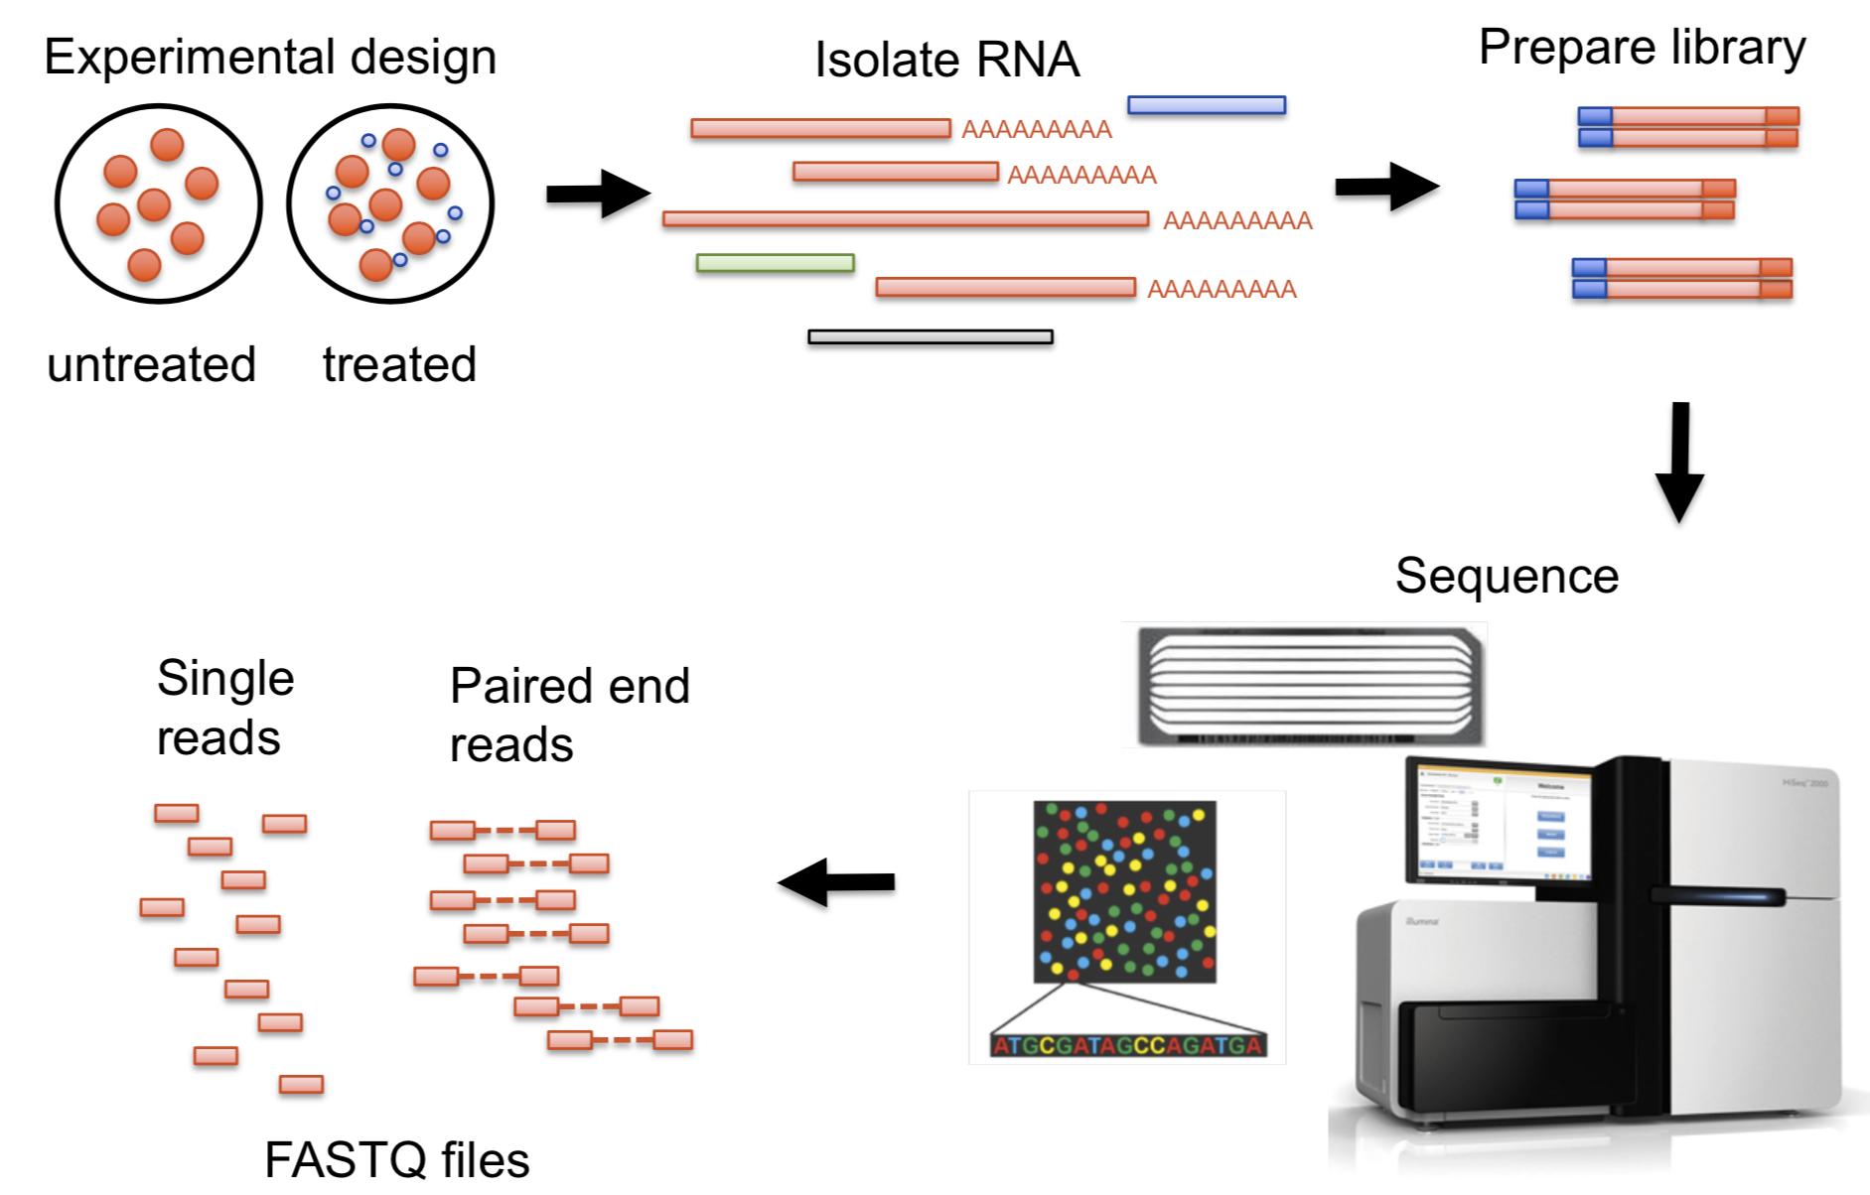
Genome Annotation is the process of identifying and labeling functional elements within a genome, such as genes, regulatory elements, and other genomic features. Gene Prediction is a key part of genome annotation that involves identifying the locations of genes within a DNA sequence. Here’s a detailed explanation suitable for a 5-mark question:
Genome Annotation:
  - Purpose: The goal of genome annotation is to assign biological functions to various regions of a genome. This includes identifying genes, exons, introns, regulatory elements, and other functional elements.
  - Steps:
    - Gene Prediction: Using computational tools and algorithms to predict the locations of genes based on the genome sequence.
    - Functional Annotation: Associating predicted genes and other features with known functions using databases and literature. This involves comparing the sequences with existing gene databases and functional annotations.
    - Structural Annotation: Determining the structure of genes, including the locations of exons, introns, and regulatory elements like promoters and enhancers.
    - Functional Validation: Experimental validation of predicted annotations to confirm their accuracy and biological relevance.
Gene Prediction:
  - Approaches:
    - Ab Initio Prediction: Uses algorithms to predict gene locations based solely on the DNA sequence and known patterns of gene structure. Common tools include AUGUSTUS, GENSCAN, and Glimmer. These tools rely on sequence motifs and statistical models.
    - Homology-Based Prediction: Identifies genes by comparing the genome sequence to known genes in other organisms. This method uses alignment tools like BLAST and involves transferring annotations from homologous genes.
    - Evidence-Based Prediction: Combines multiple sources of evidence, such as RNA-seq data, to improve prediction accuracy. This method integrates information from experimental data, such as expressed sequences or proteomics data.
Applications:
  - Functional Genomics: Understanding gene functions and interactions by annotating and predicting genes in newly sequenced genomes.
  - Comparative Genomics: Comparing gene annotations across different species to study evolutionary relationships and functional conservation.
  - Disease Research: Identifying genes associated with diseases by annotating human and model organism genomes.
Challenges:
  - Accuracy: Predictions may be inaccurate due to the complexity of gene structures and the limitations of computational models.
  - Incomplete Data: Some regions of the genome may be poorly annotated or missed due to limitations in current prediction tools and methods.
Importance:
  - Biological Insights: Genome annotation provides critical insights into the functional elements of a genome, aiding in the understanding of gene functions, regulatory mechanisms, and overall genome organization.
  - Research and Medicine: Accurate gene prediction and annotation are essential for functional genomics research and for translating genomic information into medical applications, such as identifying disease-causing mutations.
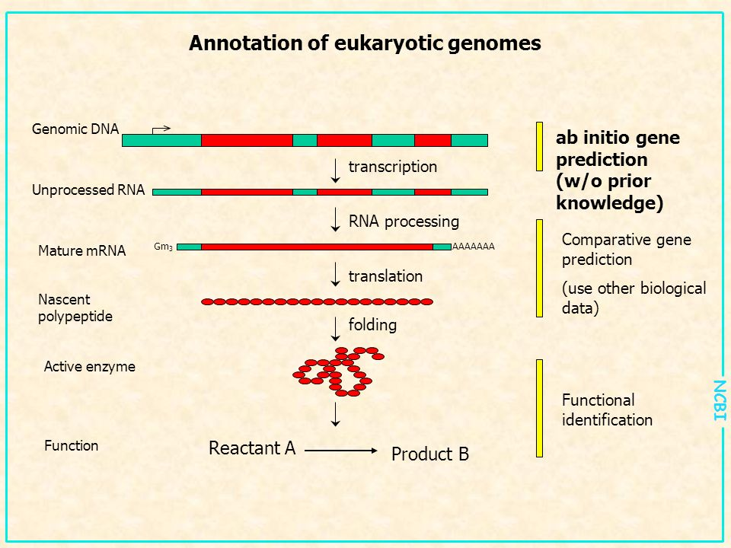
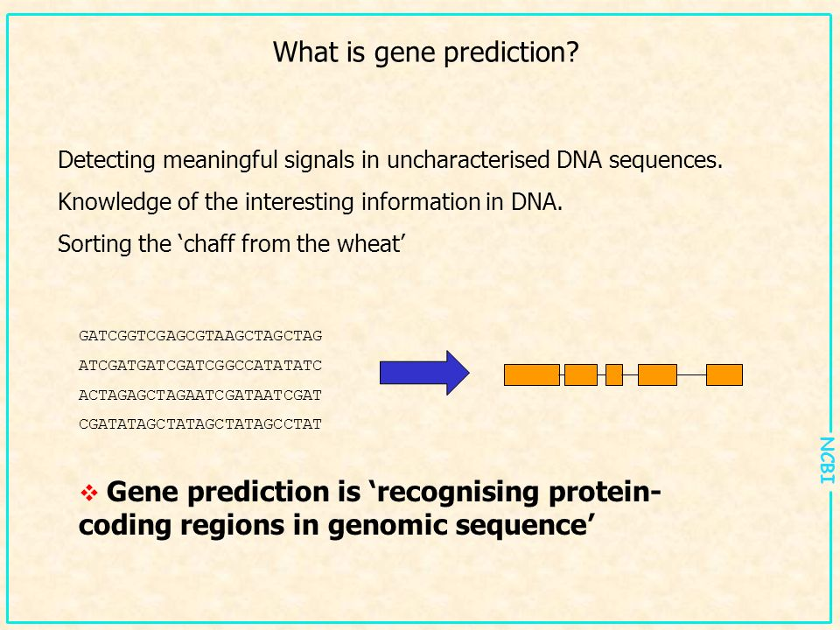
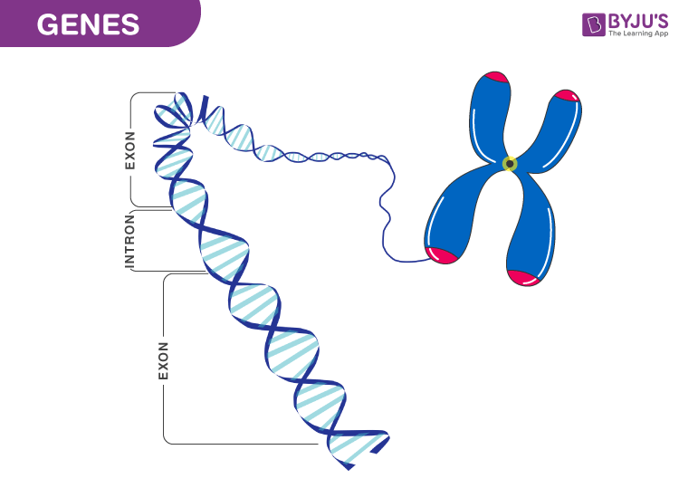
Gene and Genome
Gene:
- Definition: A gene is a segment of DNA that contains the instructions for synthesizing proteins or RNA molecules. Genes are the fundamental units of heredity and are responsible for determining an organism’s traits by encoding the information needed to produce specific proteins or RNA molecules.
- Structure: Genes consist of exons (coding regions) and introns (non-coding regions). The exons are transcribed into mRNA and translated into proteins, while introns are transcribed but typically spliced out during mRNA processing.
- Function: Genes provide the template for the synthesis of proteins or RNA, which perform a wide range of functions in the cell, including enzyme catalysis, structural support, and regulation of metabolic pathways.
Genome:
- Definition: The genome is the complete set of genetic material in an organism, including all of its genes and non-coding sequences. It encompasses all the DNA in a cell, including both the genes and the intergenic regions (regions between genes).
- Structure: In eukaryotes, the genome includes the DNA in the nucleus (nuclear genome) and, in some cases, DNA in organelles like mitochondria and chloroplasts (mitochondrial and chloroplast genomes). In prokaryotes, the genome is typically a single circular DNA molecule.
- Function: The genome contains all the genetic information necessary for the growth, development, and reproduction of an organism. It provides the blueprint for the entire organism's biological functions and characteristics.
Key Differences:
Scope:
  - Gene: Represents a specific segment of DNA that codes for a particular protein or RNA molecule.
  - Genome: Refers to the entire collection of genetic material in an organism, including all genes and non-coding regions.
Size:
  - Gene: Typically ranges from a few hundred to several thousand base pairs in length.
  - Genome: Includes the total DNA of an organism, which can range from millions to billions of base pairs, depending on the organism.
Function:
  - Gene: Focuses on coding for specific proteins or RNA products.
  - Genome: Provides the complete genetic blueprint for the organism, encompassing all genetic information needed for its development and function.
Components:
  - Gene: Includes coding regions (exons) and non-coding regions (introns).
  - Genome: Includes all genes, regulatory sequences, and non-coding regions, such as repetitive DNA and intergenic regions.
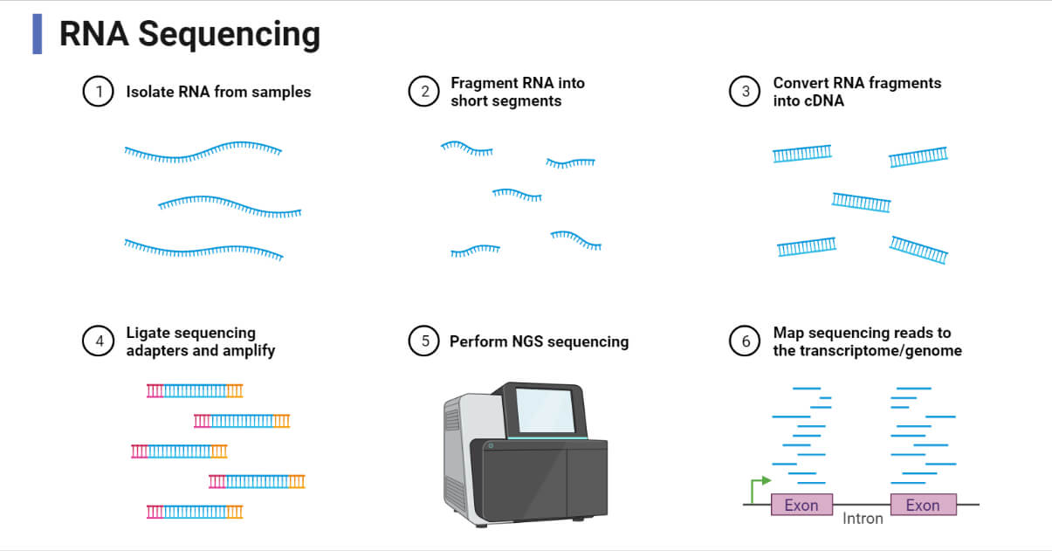
RNA Sequencing and Analysis
RNA Sequencing (RNA-seq) is a next-generation sequencing (NGS) technique used to study the entire transcriptome, providing a comprehensive view of all the RNA molecules present in a sample. It enables researchers to examine gene expression, identify novel transcripts, and understand complex transcriptional processes.

Steps in RNA Sequencing:
Here's a breakdown of the steps, summarized in a way that's easy to remember:
1. Isolate RNA:
- Start with your biological samples (e.g., cells, tissues).
- Extract the RNA molecules, which carry genetic information.
2. Fragment RNA:
- Cut the RNA molecules into smaller pieces. This makes them easier to sequence.
3. Convert to cDNA:
- Turn the RNA fragments into DNA copies (cDNA). This is because sequencing machines are designed to read DNA.
4. Add Adapters:
- Attach special tags (adapters) to the ends of the cDNA fragments. These help the sequencing machine identify and read the DNA.
5. Sequence:
- Use a high-throughput sequencing machine to determine the order of nucleotides (A, T, C, G) in the cDNA fragments.

6. Map Reads to Reference:
- Compare the sequenced DNA fragments to a reference genome or transcriptome. This helps identify which genes they came from.

Applications of RNA Sequencing:
Gene Expression Profiling:
  - RNA-seq provides a quantitative measure of gene expression levels, enabling the comparison of gene expression under different conditions (e.g., healthy vs. diseased tissue).
Novel Transcript Discovery:
  - RNA-seq can identify previously unknown transcripts, alternative splicing events, fusion genes, and non-coding RNAs.
Alternative Splicing Analysis:
  - It enables the study of alternative splicing events, where a single gene can produce multiple transcript variants, contributing to the complexity of gene regulation.
Single-Cell RNA Sequencing (scRNA-seq):
  - Allows the profiling of gene expression at the single-cell level, providing insights into cell heterogeneity, developmental processes, and rare cell populations.
Functional Genomics:
  - RNA-seq helps in understanding gene function, regulatory networks, and the effects of genetic mutations on gene expression.

Advantages of RNA Sequencing:
- Comprehensive: RNA-seq captures both known and novel RNA species, providing a global view of the transcriptome.
- Quantitative: Offers precise quantification of gene expression levels across a wide dynamic range.
- Unbiased: Does not require prior knowledge of gene sequences, unlike microarrays, allowing the discovery of new genes and transcripts.

Challenges of RNA Sequencing:
- Data Complexity: RNA-seq generates vast amounts of data, requiring robust computational tools and resources for data analysis.
- Cost: While the cost of RNA-seq has decreased, it remains higher than some traditional methods like qPCR or microarrays.
- Technical Variability: RNA degradation, batch effects, and differences in library preparation can introduce variability into the data, necessitating careful experimental design and data normalization.

Differential Gene Expression Analysis (DGE) is a method used in bioinformatics to identify changes in gene expression levels between different conditions, groups, or time points. It helps in understanding which genes are upregulated or downregulated in response to specific treatments, environmental changes, diseases, or developmental stages.

Key Concepts of Differential Gene Expression Analysis:
Purpose:
  - To identify genes that show significant differences in expression levels between two or more experimental conditions (e.g., healthy vs. diseased, treated vs. untreated).
  - To understand the molecular mechanisms underlying biological processes and identify potential biomarkers for disease diagnosis or therapeutic targets.
Workflow of Differential Gene Expression Analysis:
Data Preprocessing:
    - Quality Control: Raw sequence data from RNA sequencing (RNA-seq) is assessed for quality using tools like FastQC to check for errors, base quality, and adapter contamination. Low-quality reads or bases are trimmed or removed.
    - Read Alignment: Processed reads are aligned to a reference genome or transcriptome using alignment tools such as HISAT2, STAR, or Bowtie. This step assigns the reads to specific genes or transcripts.
    - Read Quantification: The number of reads aligned to each gene or transcript is counted using tools like HTSeq, featureCounts, or Salmon. This quantification provides raw read counts for each gene across all samples.
Normalization:
    - Normalization: Raw read counts are normalized to account for factors like sequencing depth and gene length that can affect expression measurements. Common normalization methods include:
      - Counts per Million (CPM): Adjusts for sequencing depth.
      - Fragments per Kilobase of transcript per Million mapped reads (FPKM) / Transcripts per Million (TPM): Adjusts for both gene length and sequencing depth.
      - DESeq2's Median of Ratios: Normalizes counts based on a sample-specific scaling factor to minimize bias.
Statistical Testing:
    - Differential expression analysis is performed using statistical methods to identify genes with significant differences in expression. Common tools include:
      - DESeq2: Uses a negative binomial model to account for overdispersion in RNA-seq data.
      - EdgeR: Employs an empirical Bayes approach to estimate dispersion and identify differentially expressed genes.
      - limma-voom: Combines linear modeling with precision weights to handle RNA-seq count data.
    - P-Value and Fold Change: Genes are considered differentially expressed based on statistical significance (e.g., p-value or adjusted p-value) and fold change (log2 fold change) between conditions.

Multiple Testing Correction:
    - Adjusting for multiple comparisons is critical to control the false discovery rate (FDR). Methods like the Benjamini-Hochberg procedure are used to adjust p-values and minimize false positives.
Visualization:
    - Results are visualized using plots such as:
      - Volcano Plots: Display statistical significance (p-value) versus fold change for all genes, highlighting significantly upregulated and downregulated genes.
      - Heatmaps: Show expression patterns of differentially expressed genes across samples.
      - MA Plots: Plot log fold changes against the average expression level, helping to visualize differences between conditions.
Applications of Differential Gene Expression Analysis:
  - Disease Research: Identifying genes that are differentially expressed in diseased versus healthy samples to understand disease mechanisms, discover biomarkers, and find potential drug targets.
  - Drug Development: Evaluating the effects of drug treatments on gene expression to understand therapeutic mechanisms or toxicity.
  - Developmental Biology: Studying changes in gene expression during different stages of development to understand regulatory pathways and gene functions.
  - Environmental and Stress Response: Investigating how organisms respond to environmental stressors, pathogens, or other stimuli by analyzing gene expression changes.
Challenges of Differential Gene Expression Analysis:
  - Batch Effects: Technical variability introduced by differences in experimental conditions, sample preparation, or sequencing runs can confound results and must be corrected for using normalization and statistical methods.
  - Biological Variability: Variability among biological replicates due to inherent differences in gene expression must be accounted for to avoid false positives.
  - Multiple Testing: High-dimensional data involves testing thousands of genes simultaneously, increasing the likelihood of false positives, which necessitates the use of correction methods like the Benjamini-Hochberg procedure.
Advantages of Differential Gene Expression Analysis:
  - Comprehensive: Enables the study of the entire transcriptome, capturing both known and novel transcripts.
  - Quantitative and Sensitive: Can detect subtle changes in gene expression levels across different conditions, even for low-abundance transcripts.

Conclusion:
Differential gene expression analysis is a powerful tool in genomics for understanding biological responses and regulatory mechanisms. By comparing gene expression levels across different conditions, researchers can uncover key genes and pathways involved in various biological processes, diseases, and treatments.

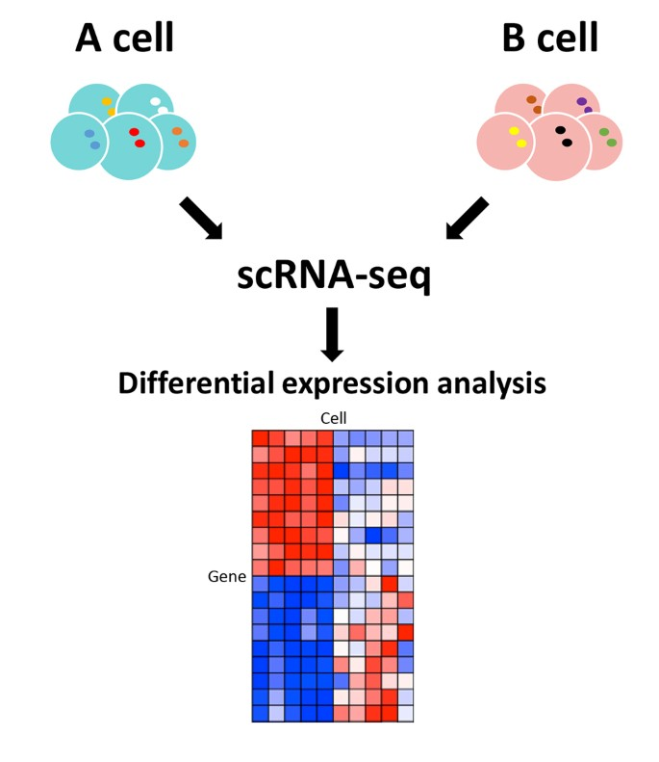

Here's a breakdown of the steps:
1. Sample Preparation:
- Start with a population of cells (e.g., A cell and B cell).
2. scRNA-seq:
- Isolate individual cells from the population.
- Perform RNA sequencing on each cell to obtain the transcriptome (the complete set of RNA transcripts).
3. Differential Expression Analysis:
- Compare the gene expression profiles of the two cell types (A cell and B cell).
- Identify genes that are differentially expressed between the cell types.
The heatmap in the image represents the differential expression analysis results. Each row corresponds to a gene, and each column corresponds to a cell. The color intensity of each cell indicates the expression level of the corresponding gene in that cell:
- Red: Higher expression in A cell
- Blue: Higher expression in B cell
- White: Similar expression in both cell types
By examining the heatmap, researchers can identify genes that are specifically upregulated or downregulated in one cell type compared to the other. This information can be used to understand the molecular basis of cell-type-specific functions and identify potential therapeutic targets.

NCBI Datasets and Repositories
The National Center for Biotechnology Information (NCBI) provides a wide range of datasets and repositories that are essential resources for biological and biomedical research. These datasets and repositories offer free access to genomic, proteomic, transcriptomic, and other types of biological data collected from various research projects worldwide. Here is an overview of some of the key NCBI datasets and repositories:

Key NCBI Datasets and Repositories:
GenBank:
  - Description: GenBank is a comprehensive public database of nucleotide sequences and their associated metadata. It includes DNA sequences from over 300,000 different organisms, encompassing genes, genomes, and sequences related to proteins.
  - Contents: Contains both coding and non-coding DNA sequences, annotated with information such as gene names, locations, protein products, and references to scientific literature.
  - Applications: Used for comparative genomics, evolutionary biology, gene discovery, and functional annotation.
RefSeq (Reference Sequence Database):
  - Description: RefSeq provides a curated collection of reference sequences, including genomic DNA, mRNA, and protein sequences. It offers a high-quality, non-redundant set of reference sequences to represent the genetic material of key organisms.
  - Contents: Includes reference sequences for major organisms, providing a comprehensive and integrated view of genomes, transcriptomes, and proteomes.
  - Applications: Serves as a standard for sequence data annotation, facilitating genomic research, variant analysis, and functional genomics.
More two repo:
Gene Expression Omnibus (GEO):
UniGene:
Databases:
• NCBI (National Center for Biotechnology Information):
A comprehensive repository that provides access to a wide range of genomic, proteomic, and bioinformatics tools and data, including sequences, literature, and biomedical information.
• • OMIM (Online Mendelian Inheritance in Man):
A database focused on human genes and genetic disorders, providing detailed descriptions of gene-disease relationships, mutations, and clinical phenotypes.
• • DMVL (Database of Variations of Mammalian Lifespans):
A specialized database containing information on genetic variations associated with lifespan differences in mammalian species.
• • DDBJ (DNA Data Bank of Japan):
A primary nucleotide sequence database that collaborates with GenBank (NCBI) and EMBL-EBI to collect, annotate, and share DNA sequence data.

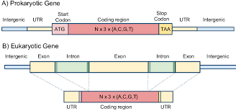
Prokaryotic Gene (Panel A):
- Intergenic Region: Non-coding DNA sequence located between genes.
- 5' Untranslated Region (UTR): Non-coding DNA sequence upstream of the coding region. It plays a role in gene regulation and translation initiation.
- Start Codon: The triplet of nucleotides (ATG) that signals the beginning of the protein-coding sequence.
- Coding Region: The region of the gene that encodes the amino acid sequence of the protein. It consists of a series of codons, each of which specifies a particular amino acid.
- Stop Codon: One of three triplets of nucleotides (TAA, TAG, or TGA) that signals the end of the protein-coding sequence.
- 3' Untranslated Region (UTR): Non-coding DNA sequence downstream of the coding region. It plays a role in gene regulation and translation termination.
- Intergenic Region: Non-coding DNA sequence located between genes.
Eukaryotic Gene (Panel B):
- Intergenic Region: Non-coding DNA sequence located between genes.
- Exon: Coding sequence that is transcribed into mRNA and translated into protein.
- Intron: Non-coding DNA sequence that is transcribed into mRNA but is removed before translation.
- 5' Untranslated Region (UTR): Non-coding DNA sequence upstream of the coding region. It plays a role in gene regulation and translation initiation.
- Coding Region: The region of the gene that encodes the amino acid sequence of the protein. It consists of a series of exons.
- 3' Untranslated Region (UTR): Non-coding DNA sequence downstream of the coding region. It plays a role in gene regulation and translation termination.
- Intergenic Region: Non-coding DNA sequence located between genes.
Key Differences:
- Introns: Eukaryotic genes contain introns, which are non-coding sequences that are removed from the mRNA before translation. Prokaryotic genes do not have introns.
- Gene Organization: Prokaryotic genes are often organized in operons, where multiple genes are transcribed under the control of a single promoter. Eukaryotic genes are generally transcribed individually.
- Gene Regulation: Eukaryotic gene regulation is more complex, involving mechanisms such as chromatin remodeling, transcription factors, and RNA processing. Prokaryotic gene regulation is simpler, primarily involving the binding of regulatory proteins to the promoter region.

Q.1 a) Define Bioinformatics. Discuss its applications in various fields. (7 Marks)
Bioinformatics is an interdisciplinary field that combines biology, computer science, mathematics, and statistics to analyze and interpret biological data. It involves the development and use of software tools, algorithms, and databases to understand complex biological systems, particularly at the molecular level.
Applications of Bioinformatics:
- Genomics: Analyzing and annotating genomes, understanding genetic variations, and discovering new genes.
- Proteomics: Studying protein structures, functions, and interactions, and identifying potential drug targets.
- Drug Discovery: Using computational tools to identify and optimize potential drug candidates by simulating their interactions with biological molecules.
- Evolutionary Biology: Comparing genetic sequences to understand evolutionary relationships and species divergence.
- Personalized Medicine: Developing tailored medical treatments based on an individual’s genetic makeup.
- Systems Biology: Integrating various biological data types to model complex biological processes and predict the outcomes of genetic and environmental interactions.
- Agriculture: Enhancing crop yield, resistance, and nutritional content through genetic analysis and engineering.

Q.2 a) Explain Sanger’s method of DNA Sequencing with a diagram. (7 Marks)
Sanger's Method of DNA Sequencing (also known as the Chain Termination Method) is a technique used to determine the nucleotide sequence of a DNA fragment. It relies on the selective incorporation of chain-terminating dideoxynucleotides (ddNTPs) during DNA replication.
Steps of Sanger Sequencing:
- DNA Template Preparation: A single-stranded DNA template is prepared from the sample to be sequenced.
- Primer Binding: A short primer complementary to the DNA template is added, providing a starting point for DNA synthesis.
- DNA Synthesis with ddNTPs: The DNA synthesis reaction involves normal deoxynucleotides (dNTPs) and modified dideoxynucleotides (ddNTPs). ddNTPs lack a 3’-OH group, causing chain termination when incorporated into the growing DNA strand.
- Gel Electrophoresis: The reaction products are separated by size using gel electrophoresis. The terminated fragments create a ladder pattern, where each band represents a DNA fragment terminated at a specific base.
- Sequence Determination: The DNA sequence is determined by reading the order of bands from the gel, which corresponds to the sequence of nucleotides in the original DNA template

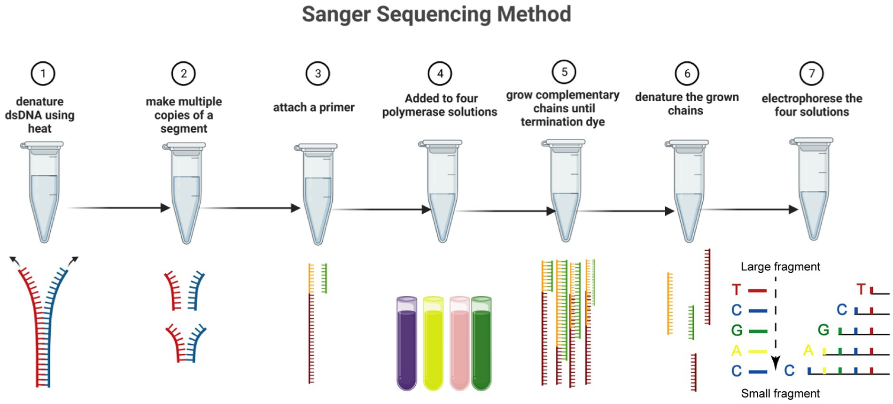

Q.2 b) Explain the central dogma of molecular biology. Describe the processes of transcription and translation, and discuss how they contribute to the flow of genetic information from DNA to protein. (8 Marks)
The Central Dogma of Molecular Biology describes the flow of genetic information within a biological system. It states that genetic information flows from DNA to RNA to Protein.
Transcription: The process by which the genetic information in DNA is copied into messenger RNA (mRNA).
  - Steps of Transcription:
    - Initiation: RNA polymerase binds to the promoter region of the gene.
    - Elongation: RNA polymerase synthesizes a complementary RNA strand using one strand of DNA as a template.
    - Termination: The RNA polymerase reaches a terminator sequence and releases the newly formed mRNA.
  - Outcome: mRNA carries the genetic code from DNA in the nucleus to the ribosomes in the cytoplasm.
Translation: The process by which mRNA is decoded to synthesize a specific protein.
  - Steps of Translation:
    - Initiation: The ribosome assembles around the mRNA and the first tRNA binds to the start codon (AUG).
    - Elongation: The ribosome moves along the mRNA, and tRNAs bring the corresponding amino acids to form a polypeptide chain.
    - Termination: The process ends when a stop codon is reached, and the newly synthesized protein is released.
  - Outcome: A functional protein is synthesized, which can perform various cellular functions.

Contribution to Genetic Information Flow:
- DNA acts as the permanent storage of genetic information.
- RNA serves as the intermediary that carries the information from DNA to the cellular machinery.
- Proteins are the end products that perform cellular functions, catalyze biochemical reactions, and regulate various biological processes.

Q.3 a) Describe different gene and genome databases. (7 Marks)
Gene and genome databases store, organize, and provide access to a wide variety of genetic and genomic information that is essential for biological research. Here are some of the major gene and genome databases:

GenBank:

  - A comprehensive public database of nucleotide sequences and their associated metadata. It provides a collection of all publicly available DNA sequences, including both coding and non-coding regions, submitted by researchers worldwide.

Ensembl:

  - A genome database that provides detailed information on the genomes of eukaryotic species, including humans, mice, and plants. It offers tools for visualizing genomic data, gene annotations, and comparative genomics.

UCSC Genome Browser:

  - A database that offers a graphical interface for exploring the genomes of various organisms. It provides a wide range of annotations, such as gene predictions, regulatory regions, and epigenetic marks, for better understanding genomic functions.

RefSeq (Reference Sequence Database):

  - A curated collection of reference sequences, including genomic DNA, mRNA, and protein sequences, that serves as a standard for annotation and analysis. It helps in understanding gene function, mutation effects, and evolutionary studies.

OMIM (Online Mendelian Inheritance in Man):

  - A comprehensive database that catalogs human genes and genetic disorders, describing their functions, clinical features, and genetic variations associated with diseases.

DDBJ (DNA Data Bank of Japan):

  - A nucleotide sequence database that collaborates with GenBank (NCBI) and EMBL-EBI to collect, annotate, and distribute DNA sequences submitted by the global research community.

dbSNP (Database of Single Nucleotide Polymorphisms):

  - A database that catalogs genetic variations, including single nucleotide polymorphisms (SNPs), and short insertions or deletions (indels) that can be used for genetic association studies and population genetics.

Q.3 b) Explain the structure of DNA and its significance in genetic information storage and transmission. (8 Marks)
Structure of DNA:
Double Helix Model:
  - DNA (Deoxyribonucleic Acid) has a double-helix structure, consisting of two long strands of nucleotides twisted around each other like a spiral staircase. This model was first proposed by Watson and Crick in 1953.

Nucleotide Composition:
  - Each nucleotide consists of three components: a phosphate group, a deoxyribose sugar, and a nitrogenous base (Adenine - A, Thymine - T, Cytosine - C, Guanine - G).
  - The sugar and phosphate form the DNA backbone, while the nitrogenous bases pair through hydrogen bonds (A-T, G-C), forming the "rungs" of the helix.
Base Pairing:
  - Complementary base pairing (A with T, G with C) is essential for the replication and transcription of genetic information, maintaining the integrity and stability of DNA.
Antiparallel Orientation:
  - The two DNA strands run in opposite directions (5' to 3' and 3' to 5'), which is crucial for replication and enzymatic activities.
Significance in Genetic Information Storage and Transmission:
Storage of Genetic Information:
  - DNA stores genetic information in the sequence of its bases, which encodes the instructions for building proteins and RNA molecules essential for cellular functions.
Accurate Replication:
  - The complementary base pairing allows DNA to be replicated precisely during cell division, ensuring that genetic information is faithfully passed from one generation to the next.
Mutation and Evolution:
  - DNA's structure allows for mutations, which can lead to genetic variation, providing the raw material for evolution and adaptation.
Transcription and Translation:
  - DNA's sequence is transcribed into RNA, which is then translated into proteins, allowing the expression of genes that determine the structure and function of cells.

Q.4 a) Explain Maxam-Gilbert method of DNA sequencing with a diagram. (7 Marks)
The Maxam-Gilbert method of DNA sequencing (also known as the chemical degradation method) was one of the first techniques developed to determine the nucleotide sequence of DNA. It is based on the chemical modification of DNA and subsequent cleavage at specific bases.
Steps of Maxam-Gilbert Sequencing:
DNA Labeling:
  - A single-stranded DNA fragment is radioactively labeled at the 5' end to facilitate detection after cleavage.
Chemical Cleavage:
  - The labeled DNA is divided into four separate reactions, each containing a different chemical that specifically cleaves the DNA at one or more types of bases:
  - G Reaction: Cleaves at guanine (G).
  - A+G Reaction: Cleaves at adenine (A) and guanine (G).
  - C Reaction: Cleaves at cytosine (C).
  - C+T Reaction: Cleaves at cytosine (C) and thymine (T).
Fragment Separation:
  - The resulting fragments of different lengths are separated by size using polyacrylamide gel electrophoresis.
Sequence Determination:
  - The gel is exposed to X-ray film to visualize the radioactive fragments. By reading the pattern from the shortest to the longest fragments, the DNA sequence can be determined.
Diagram: (You can draw a diagram showing the labeled DNA, chemical cleavage reactions, and gel electrophoresis, similar to the one used for Sanger sequencing but focusing on the chemical cleavage process.)
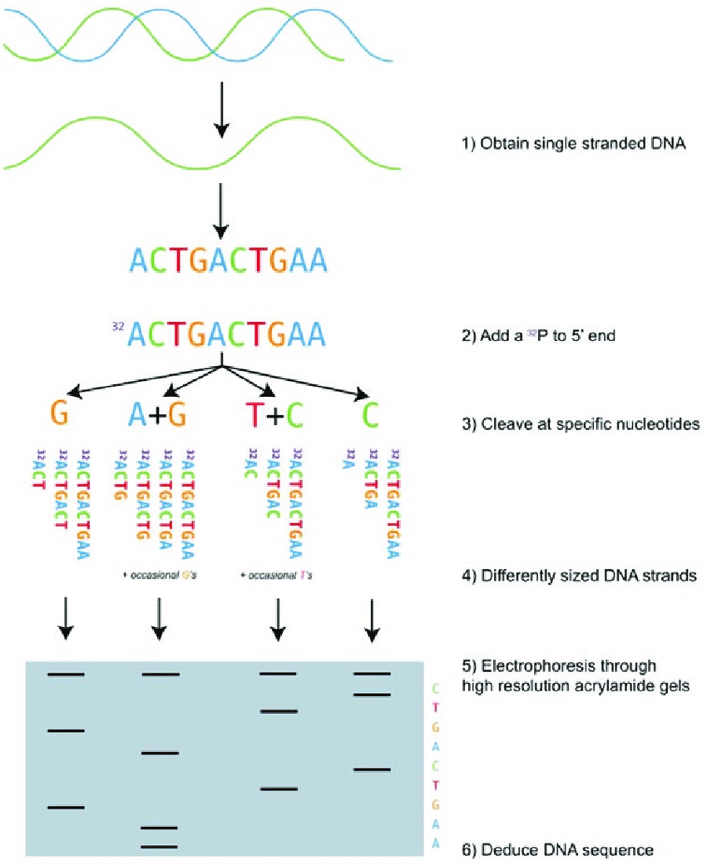

Q.4 b) Discuss the different types of genes and their roles in the cell. (8 Marks)
Genes are segments of DNA that encode functional products, such as proteins or RNA molecules. They play various roles in cellular processes. Here are the different types of genes and their functions:
Structural Genes:
  - Encode proteins that form the structure of the cell or tissues, such as collagen in connective tissues or keratin in hair and nails.
Regulatory Genes:
  - Control the expression of other genes by producing regulatory proteins like transcription factors. These genes play a key role in cellular processes, such as growth, development, and response to environmental signals.
Housekeeping Genes:
  - Essential for maintaining basic cellular functions. These genes are constantly expressed at a steady level in all cells, and include genes involved in metabolic processes, such as those encoding enzymes for glycolysis.
Oncogenes:
  - Genes that, when mutated or overexpressed, have the potential to cause normal cells to become cancerous. They promote cell growth and division.
Tumor Suppressor Genes:
  - Inhibit cell growth and division. When these genes are inactivated or deleted, they can contribute to the development of cancer.
Immune System Genes:
  - Encode proteins involved in immune responses, such as antibodies, T-cell receptors, and cytokines, providing defense against pathogens.
Apoptotic Genes:
  - Involved in the regulation of programmed cell death (apoptosis), crucial for removing damaged or unwanted cells. Examples include the Bcl-2 family of proteins.
Mitochondrial Genes:
  - Found in mitochondrial DNA, these genes encode proteins essential for mitochondrial function and energy production.

